**DESIGN AND IMPLEMENTATION OF AN ONLINE SCHOOL FEES PAYMENT SYSTEM (Case Study of Staff Demonstration School, Federal Polytechnic, Mubi)”**

**BY**

**HASSAN AMIR MUHAMMED**

**ST/CS/ND/21/054**

**DEPARTMENT OF COMPUTER SCIENCE,**

**SCHOOL OF SCIENCE AND TECHNOLOGY,**

**FEDERAL POLYTECHNIC, MUBI, ADAMAWA STATE.**

**IN PARTIAL FULFILMENT OF THE REQUIREMENT FOR THE AWARD OF NATIONAL DIPLOMA (ND) IN COMPUTER SCIENCE.**

**SEPTEMBER, 2023**

# DECLARATION

I hereby declare that the work in this project titled “**Design and Implementation of an Online School Fees Payment System (Case Study of Staff Demonstration School, Federal Polytechnic, Mubi)”** was performed by me under the supervision of Mal. Ibrahim Bashir Tukur. The information derived from literatures has been duly acknowledged in the text and a list of references provided. The work embodied in this project is original and had not been submitted in part or in full for any other diploma or certificate of this or any other institution.

Hassan Amir Muhammed \_\_\_\_\_\_\_\_\_\_\_\_\_\_\_\_\_\_\_

(ST/CS/ND/21/054) Signature/Date

# CERTIFICATION

This project work titled “**Design and Implementation of a Student Electronic Portal with Result PIN (Case Study of Staff Demonstration School, Federal Polytechnic, Mubi)”** meets the regulations governing the award of National Diploma (ND) in Computer Science, Federal Polytechnic Mubi, Adamawa State

Mal. Ibrahim Bashir Tukur \_\_\_\_\_\_\_\_\_\_\_\_\_\_\_\_\_\_

(Project Supervisor) Sign/Date

Mallam Adamu Mubi Garba \_\_\_\_\_\_\_\_\_\_\_\_\_\_\_\_\_\_

(Head of Department) Sign/Date

Abdulrahaman Saidu \_\_\_\_\_\_\_\_\_\_\_\_\_\_\_\_\_

(External Examiner) Sign/Date

# DEDICATION

I dedicate this project work to Almighty God for granting me the ability to accomplish this work successfully.

# ACKNOWLEDGEMENTS

I want to acknowledge Almighty God for his infinite mercy and protection throughout my academic activities. And for the understanding in achieving my academic success.

I also recognize my Supervisor Mal. Ibrahim Bashir Tukur, who took time, despite his busy schedule to direct and guide me throughout this research work.

I also acknowledge the Head of Department Computer Science Mal. Mustapha Kassim for his moral encouragement throughout my period of study. I also acknowledge all Staff of Computer Science Department for their support and encouragement and the knowledge they’ve impacted on me throughout my studies.

I also want to appreciate my lovely mum for her love and care and for giving me the opportunity to be trained and achieve my dreams.

Finally, I appreciate the efforts of my Uncles, for their encouragement and support throughout the course of my study. And also my friends and relatives, course mates and all well-wishers. I love you all, may the Almighty God bless you abundantly, Amen.

**TABLE OF CONTENTS**

[DECLARATION ii](#_Toc146620026)

[CERTIFICATION iii](#_Toc146620027)

[DEDICATION iv](#_Toc146620028)

[ACKNOWLEDGEMENTS v](#_Toc146620029)

[LIST OF FIGURES viii](#_Toc146620030)

[LIST OF TABLES ix](#_Toc146620031)

[ABSTRACT x](#_Toc146620032)

[CHAPTER ONE 11](#_Toc146620033)

[INTRODUCTION 11](#_Toc146620034)

[1.1 Background of the Study 11](#_Toc146620035)

[1.2 Problem Statement 12](#_Toc146620036)

[1.3 Aim and Objectives 13](#_Toc146620037)

[1.4 Significance of the Study 13](#_Toc146620038)

[1.5 Scope of the Study 13](#_Toc146620039)

[1.6 Definition of Some Operational Terms 13](#_Toc146620040)

[CHAPTER TWO 15](#_Toc146620041)

[LITERATURE REVIEW 15](#_Toc146620042)

[2.1 Introduction 15](#_Toc146620043)

[2.2 Benefits of Online School Fee Payment Systems 15](#_Toc146620044)

[2.2.1 Convenience and Accessibility 15](#_Toc146620045)

[2.2.2 Administrative Efficiency 15](#_Toc146620046)

[2.2.3 Enhanced Security 16](#_Toc146620047)

[2.3 Challenges and Considerations 16](#_Toc146620048)

[2.5 Information Management System 17](#_Toc146620049)

[2.5.1 Importance of Information Management Systems 17](#_Toc146620050)

[2.6 Database Management System 17](#_Toc146620051)

[2.7 Summary of Literatures 18](#_Toc146620052)

[CHAPTER THREE 19](#_Toc146620053)

[SYSTEM ANALYSIS AND DESIGN 19](#_Toc146620054)

[3.1 Introduction 19](#_Toc146620055)

[3.2 Disadvantages of the existing system 19](#_Toc146620056)

[3.3 Advantages of the proposed system 19](#_Toc146620057)

[3.4 The Proposed Method 20](#_Toc146620058)

[3.5 Method of Data Collection 21](#_Toc146620059)

[3.6 System Design 22](#_Toc146620060)

[3.6.1 Algorithm Diagram 22](#_Toc146620061)

[Table 3.1: Payment Table 23](#_Toc146620062)

[3.7 System Requirement Specification 30](#_Toc146620063)

[3.7.3 Personnel Requirements 30](#_Toc146620064)

[CHAPTER FOUR 31](#_Toc146620065)

[RESULTS AND DISCUSSION 31](#_Toc146620066)

[4.1 Introduction 31](#_Toc146620067)

[4.2 Results 31](#_Toc146620068)

[4.3 Discussion 37](#_Toc146620069)

[4.4 User manual 38](#_Toc146620070)

[CHAPTER FIVE 39](#_Toc146620071)

[SUMMARY, CONCLUSION AND RECOMMENDATION 39](#_Toc146620072)

[5.1 Summary 39](#_Toc146620073)

[5.2 Conclusion 39](#_Toc146620074)

[5.3 Recommendations 39](#_Toc146620075)

[5.4 Contribution to Knowledge 39](#_Toc146620076)

[5.5 Area for further work 39](#_Toc146620077)

[REFERENCES 40](#_Toc146620078)

[APPENDIX A 43](#_Toc146620079)

[APPENDIX B 50](#_Toc146620080)

# LIST OF FIGURES

Figure 3.1: UML class diagram - - - - - - - 25

Figure 3.2: Database entity relationship diagram - - - - 31

Figure 3.3: Login interface - - - - - - 31

Figure 3.4: Create Profile interface - - - - - 32

Figure 3.5: Complete Registration interface - - - - - 33

Figure 4.1: Welcome interface - - - - - - - 35

Figure 4.2: Home page interface - - - - - - - 35

Figure 4.3: Login page interface - - - - - - - 36

Figure 4.4: Signup page interface - - - - - - 36

Figure 4.5: Edit profile page interface - - - - - - 37

Figure 4.6: Create announcement interface - - - - - 37

Figure 4.7: Announcement interface - - - - - - 38

Figure 4.8: Upload result interface - - - - - - 38

Figure 4.9: Publish result interface - - - - - - 39

Figure 4.10: Student registration slip interface - - - - - 40

Figure 4.11: Staff dashboard interface - - - - - - 41

Figure 4.12: Student dashboard interface - - - - - - 41

# LIST OF TABLES

Table 3.1: access - - - - - - - 26

Table 3.2: Administrative - - - - - - 26

Table 3.3: Announcement - - - - - - 26

Table 3.4: Classes - - - - - - - 26

Table 3.5: Current Session - - - - - - 27

Table 3.6: Result - - - - - - - 27

Table 3.7: Students - - - - - - - 28

Table 3.8: Subjects - - - - - - - 29

Table 3.9: Teachers - - - - - - - 29

Table 3.10: Users - - - - - - - 30

# **ABSTRACT**

*The advent of information technology has brought about a huge effect on the entire education system and also has made the student to shift from manual systems to computerised systems. Most of the system that involves manual work has been automated efficiently. Student registration process in Federal Polytechnic, Mubi Staff Secondary School involves filling registration forms manually, getting it signed by respective Management and then getting the documents, then the registration forms are submitted in the Administrative office, also the existing system involves manual process of generating results and given to students which is liable to forgery. This process is very laborious and time consuming. A Student E-Portal is therefore developed to simplify the manual procedure. The methodology involves using PHP, Apache and MySQL while front-end is designed with PHP, the back-end is managed with MySQL. The system is more secured and user-friendly. The researcher also makes recommendation that the system be implemented by Federal Polytechnic, Mubi Staff Secondary School and other secondary schools as well. Also, further researcher should be made to include online payment as the new system is limited in that aspect.*

# CHAPTER ONE

# INTRODUCTION

## 1.1 Background of the Study

Education plays a vital role in the development of any nation. In recent years, there has been a significant shift towards the integration of technology in the education sector. One area where technology has made a significant impact is the payment of school fees. Traditional methods of school fee payment, such as cash or checks, can be time-consuming, inefficient, and prone to errors. Online school fee payment systems have emerged as a viable solution, offering convenience, efficiency, and enhanced security. Online school fee payment systems offer several advantages over traditional payment methods. They provide a convenient platform for parents or guardians to make fee payments from anywhere at any time, eliminating the need for physical visits to the school. These systems also reduce the administrative burden on school staff by automating payment processing, record-keeping, and fee reconciliation. Furthermore, online payment systems enhance transparency and accountability, as both the school and parents can track payment transactions and generate digital receipts.

According to a recent study by Balogun and Adetokunboh (2021), the adoption of online payment systems in educational institutions has gained momentum due to the increasing reliance on technology and the need for streamlined administrative processes. The study emphasized that online fee payment systems eliminate the need for parents or guardians to physically visit the school to make payments, reducing the associated inconveniences and time-consuming tasks. Furthermore, online payment systems offer secure transaction channels, reducing the risks associated with handling cash and minimizing the chances of misplacing payment records.

In addition to the benefits for parents and guardians, online payment systems also offer advantages to educational institutions. Kao and Li (2020), highlighted that online payment systems can enhance administrative efficiency by automating fee collection processes, reducing paperwork, and improving record-keeping. By integrating the online payment system with existing school databases, schools can streamline financial management, generate accurate reports, and facilitate easier reconciliation of payments.

Several studies have highlighted the benefits of online school fee payment systems in educational institutions. A study by Thakur and Kotecha (2020), examined the impact of online fee payment systems on the efficiency and transparency of fee collection processes in Indian schools. The findings revealed that the implementation of online payment systems significantly reduced the time and effort required for fee management, improved financial reporting accuracy, and enhanced parent-school communication.

Devi and Rani (2021), investigated the challenges faced by parents and schools in the manual fee payment process and explored the advantages of online payment systems. The study emphasized that online payment systems can enhance data security, reduce cash handling risks, and improve overall financial management in schools.

In the context of Nigeria, where the Federal Polytechnic, Mubi Staff School is located, the adoption of online payment systems in educational institutions is still in its early stages. However, there is a growing recognition of the need to modernize fee collection processes and leverage technology for improved efficiency. A case study by Adamu et al. (2021), examined the implementation of an online fee payment system in a Nigerian university and highlighted the positive impact on fee collection, reduction of fraud cases, and enhanced financial transparency.

However, despite the growing trend towards online payment systems, many educational institutions, including the Federal Polytechnic, Mubi Staff School, still rely on manual fee collection methods. This reliance on manual systems often leads to challenges such as delays in fee processing, errors in recording payments, and increased administrative workload.

## 1.2 Problem Statement

Despite the numerous benefits associated with online school fee payment systems, many educational institutions, including the Federal Polytechnic, Mubi Staff School, still rely on manual and traditional methods for fee collection. This reliance on manual systems often leads to challenges such as delays in fee processing, misplacement of payment records, and the inconvenience of parents physically visiting the school to make payments. Therefore, there is a need to design and implement an online school fee payment system to address these challenges and improve the overall fee payment process at the Federal Polytechnic, Mubi Staff School.

The problem statement for the design and implementation of the online school fee payment system for the Federal Polytechnic, Mubi Staff School can be summarized as follows:

1. The reliance on manual and traditional fee payment methods at the Federal Polytechnic, Mubi Staff School leads to inefficiencies in the fee collection process, including delays in fee processing and errors in recording payments.
2. The current fee payment system lacks a convenient and secure online platform, requiring parents and guardians to physically visit the school to make payments, causing inconvenience and consuming valuable time.
3. The absence of an integrated online payment system results in challenges in financial management and record-keeping, making it difficult to generate accurate reports and reconcile payments.
4. The existing fee payment methods do not provide adequate security measures, leaving room for potential risks, such as loss of payment records and unauthorized access to sensitive financial information.

## 1.3 Aim and Objectives

The aim of this project is to design and implement an online school fee payment system for the Federal Polytechnic, Mubi Staff School. The specific objectives are as follows:

1. To identify the requirements and functionalities of an online school fee payment system.
2. To develop a user-friendly and secure online platform for fee payment.
3. To integrate the online payment system with existing school databases for seamless record-keeping.
4. To evaluate the effectiveness and user satisfaction of the implemented system.

## 1.4 Significance of the Study

The findings of this study will be beneficial to the Federal Polytechnic, Mubi Staff School and other educational institutions that are yet to adopt online school fee payment systems. The study will provide insights into the design and implementation of an efficient and secure payment system that can streamline fee collection processes, reduce administrative burdens, and enhance parent-school communication. Additionally, the study will contribute to the existing literature on online payment systems in educational settings.

## 1.5 Scope of the Study

The scope of this study encompasses the design and implementation of an online school fee payment system specifically tailored for the Federal Polytechnic, Mubi Staff School. The study will focus on the following areas; Development of an Online Payment Platform, Integration with Existing School Databases, Security Measures. Also, the study will focus on providing a positive user experience for parents and guardians. The online payment system will be designed to be intuitive, responsive, and accessible from various devices. Additionally, the system will incorporate features to facilitate effective communication between the school and parents, such as automated payment notifications and online receipt generation.

## 1.6 Definition of Some Operational Terms

**Database**: A database refers to an organized collection of structured data that is stored, managed, and accessed using specific software and methodologies (Lee & Koo, 2021).

**Online School Fee Payment System:** An online school fee payment system refers to a digital platform that allows parents or guardians to make school fee payments electronically through the internet (Jelena & Zoran, 2020).

**Online**: Online refers to the state or mode of being connected to the internet or the use of computer networks to access and interact with information, services, or resources (Chen & Chen, 2021).

**Payment**: It involves the settlement of financial transactions between parties and can be conducted using various methods such as cash, checks, credit/debit cards, and electronic transfers (Sutanto et al., 2020).

**Portal**: A portal refers to a web-based platform or gateway that provides access to various resources, information, and services (Li et al., 2020).

**School Fees**: School fees refer to the financial charges or expenses that parents or guardians are required to pay to educational institutions for the provision of academic programs, facilities, and services (Alcott & Rose, 2021).

**System**: A system refers to a collection of interconnected components, processes, or elements that work together to achieve a specific purpose or objective (Huang, 2021).

# CHAPTER TWO

# LITERATURE REVIEW

## 2.1 Introduction

This chapter presents a comprehensive literature review on online school fee payment systems, highlighting their benefits, challenges, and best practices. The review aims to provide a theoretical foundation and insights into the design and implementation of an effective online payment system for educational institutions, with a specific focus on the Federal Polytechnic, Mubi Staff School.

## 2.2 Benefits of Online School Fee Payment Systems

Online school fee payment systems have gained significant attention in recent years as educational institutions seek to leverage technology to streamline administrative processes and enhance parent-school interactions. These systems provide a digital platform for parents or guardians to conveniently and securely make fee payments online.

Online school fee payment systems offer numerous advantages over traditional payment methods. Research by Balogun and Adetokunboh (2021) emphasizes that these systems enhance convenience for parents and guardians by eliminating the need to physically visit the school for fee payments. Online payments allow for 24/7 accessibility, enabling users to make payments at their convenience, reducing time and effort.

Furthermore, online payment systems enhance administrative efficiency. Kao and Li (2020) note that these systems automate fee collection processes, reducing paperwork and administrative burden. By integrating with school databases, accurate and real-time payment records can be generated, simplifying financial management and reconciliation of payments.

Security is a critical aspect of online payment systems. Wahyudi *et al*. (2021) stress the importance of implementing robust security measures to protect sensitive financial information and prevent unauthorized access. Encryption protocols, secure payment gateways, and user authentication mechanisms are key components in ensuring the security and integrity of online transactions.

## 2.2.1 Convenience and Accessibility

Online payment systems offer convenience by eliminating the need for parents or guardians to physically visit the school to make payments. Users can access the system at anytime from anywhere with internet connectivity, providing flexibility and ease of use (Balogun & Adetokunboh, 2021). This convenience saves time and effort for both parents and school staff.

## 2.2.2 Administrative Efficiency

Online payment systems automate and streamline the fee collection process, reducing administrative workload and paperwork. The integration of these systems with school databases enables accurate record-keeping, easy tracking of payments, and efficient generation of financial reports (Kao & Li, 2020). Administrative staff can focus on higher-value tasks, improving overall operational efficiency.

## 2.2.3 Enhanced Security

Implementing robust security measures is crucial in online payment systems to protect sensitive financial information and prevent unauthorized access. Secure payment gateways, encryption protocols, and user authentication mechanisms ensure the confidentiality and integrity of transactions (Wahyudi et al., 2021). These security features instill trust in users and protect against potential risks.

## 2.3 Challenges and Considerations

Despite the benefits, online school fee payment systems also present challenges that need to be addressed. One challenge is the digital divide and accessibility. According to Jelena and Zoran (2020), disparities in internet access and technological infrastructure may hinder the adoption and usage of online payment systems, especially in certain regions or communities.

User acceptance and trust are crucial for the success of online payment systems. Sutanto, Palme, and Chua (2020) highlight the importance of addressing perceived risks and concerns related to security, privacy, and reliability. Building user confidence through transparent security measures and effective communication is essential.

Integration with existing school systems is a critical consideration. Lee and Koo (2021) emphasize the need for database integration to ensure seamless data exchange and synchronization between the online payment system and other school management systems. This integration facilitates efficient record-keeping, report generation, and data analysis.

Several best practices can guide the design and implementation of an effective online school fee payment system. A user-centered design approach is crucial for creating a user-friendly interface. Huang and Lu (2020) suggest involving parents, guardians, and school stakeholders in the design process to ensure the system meets their needs and preferences.

Usability testing and continuous improvement are vital. Yusoff and Mohamad (2021) emphasize the importance of iterative testing and user feedback to identify and address usability issues, ensuring a smooth and intuitive user experience.

Communication and support channels play a significant role. Clear and timely communication regarding the availability, benefits, and usage of the online payment system is essential for user adoption. Providing multiple support channels, such as helplines or FAQs, assists users in resolving any issues or concerns they may encounter.

## 2.5 Information Management System

An information management system (IMS) is a comprehensive framework that encompasses the processes, technologies, and strategies used to collect, organize, store, retrieve, and analyze information within an organization. An information management system refers to the integrated set of processes, tools, and technologies that enable organizations to effectively manage their information assets. It includes various components such as data collection, storage, retrieval, analysis, and dissemination (Khumalo, 2020).

## 2.5.1 Importance of Information Management Systems

1. Decision Making and Strategic Planning IMS enables organizations to gather and analyze relevant data, providing valuable insights that support informed decision-making and strategic planning (Delen, 2021). By providing accurate and up-to-date information, IMS enhances the ability of managers to make informed decisions in a timely manner.
2. Improved Efficiency and Productivity Efficient information management improves operational efficiency and productivity. By centralizing information, eliminating duplication, and automating processes, IMS streamlines workflows, reduces manual effort, and enhances overall efficiency (Wang, Liu, & Lee, 2021).
3. Enhanced Collaboration and Knowledge Sharing IMS facilitates effective collaboration and knowledge sharing within organizations. It provides a centralized platform for employees to access and share information, fostering collaboration, and enabling knowledge transfer (Al-Khouri & Abu-Jarour, 2020).

## 2.6 Database Management System

Database Management Systems (DBMS) are essential tools for storing, organizing, managing, and retrieving data efficiently. DBMS provide a structured approach to store and retrieve data, ensuring data integrity, security, and scalability for organizations.

Recent studies have highlighted the significance of DBMS in various domains. A research article by Ramakrishnan and Gehrke (2020), emphasized that DBMS are crucial for managing the increasing volumes of data generated in today's digital world. The study highlighted that DBMS enable organizations to handle diverse data types, ensure data consistency, and support complex data queries.

One of the key functions of DBMS is data storage and organization. DBMS provide a structured framework for storing data in tables, defining relationships between tables, and enforcing data integrity through constraints. These systems often employ relational models, such as the widely-used SQL (Structured Query Language), to manage data in a tabular format. A study by Elmasri and Navathe (2019), emphasized that DBMS enable efficient data storage, normalization, and indexing to optimize data retrieval performance.

Moreover, DBMS offer tools for data retrieval and manipulation. These systems allow users to query the database using SQL or other query languages to retrieve specific data based on specified criteria. DBMS also support complex operations such as joining multiple tables, filtering data, and aggregating results. A research article by Rizvi et al. (2021) highlighted the role of DBMS in enabling efficient and accurate data retrieval, facilitating decision-making and analysis.

DBMS also provide mechanisms for data security and access control. These systems enable organizations to define user roles and permissions, ensuring that only authorized users can access and modify the data. DBMS also offer features such as data encryption, backup, and recovery to protect against data breaches and system failures. A study by Motahari-Nezhad et al. (2021) emphasized the importance of DBMS in ensuring data privacy, integrity, and availability, particularly in the context of sensitive and regulated data.

The advent of advanced technologies has further enhanced the capabilities of DBMS. Distributed DBMS enable data storage and processing across multiple servers, providing scalability, fault tolerance, and high availability. NoSQL (Not Only SQL) DBMS have emerged as alternatives to traditional relational DBMS, offering flexible data models and scalability for handling large volumes of unstructured and semi-structured data. A research article by Ghazal *et al.* (2020), discussed the benefits and challenges of NoSQL DBMS in big data environments.

## 2.7 Summary of Literatures

This chapter presented a comprehensive literature review on online school fee payment systems. The review highlighted the benefits of online payment systems, including convenience for parents, administrative efficiency, and enhanced security. Challenges such as the digital divide, user acceptance, and system integration were discussed. Best practices and recommendations were provided to guide the design and implementation of an effective online payment system.

# CHAPTER THREE

# SYSTEM ANALYSIS AND DESIGN

## 3.1 Introduction

This chapter contains the system design and analysis of the proposed system, the disadvantages of the existing system in Demonstration Staff School, Federal Polytechnic, Mubi, the advantages of the proposed system over the existing system, the requirements (Hardware and Software), the design and the system architecture.

## 3.2 Disadvantages of the existing system

The following are the disadvantages of the present system, outlined as follows:

1. The existing system likely involves a lot of manual work, such as filling out paper forms, handling cash or cheques, and maintaining physical records.
2. Parents and guardians may have to visit the school premises physically to make fee payments.
3. The existing system might only accept a few payment methods, such as cash or cheques.
4. The manual processing of fees can be time-consuming for school administrators and staff, diverting their focus from other critical tasks.
5. The existing system may not be integrated with other school management systems, leading to duplication of efforts and data discrepancies.

## 3.3 Advantages of the proposed system

The proposed Online School Fee Payment System for Demonstration Staff School, Federal Polytechnic, Mubi offers numerous advantages over the existing manual system. Here are some of the key advantages:

1. Convenience for Parents and Guardians: Parents and guardians can make fee payments from the comfort of their homes or offices, eliminating the need to visit the school premises physically.
2. 24/7 Accessibility: The online system allows parents to access the fee payment platform at any time, making it convenient for them to pay fees, view payment history, and download receipts at their convenience.
3. Multiple Payment Options: The system will support various payment methods, including credit/debit cards, online banking, and mobile wallets, providing flexibility to parents in choosing their preferred payment mode.
4. Secure Payment Processing: Integration with a reliable and secure payment gateway will ensure safe and encrypted transactions, minimizing the risk of fraud and ensuring the confidentiality of payment details.
5. Improved Data Accuracy: With automated processes and centralized data storage, the system will reduce the chances of errors in fee calculation and maintain accurate payment records.
6. Easy Fee Reconciliation: The system will make it easier for school administrators to reconcile fee payments with student records, reducing manual effort and the likelihood of discrepancies.
7. Integration with School Management System: The online fee payment system can be integrated with the existing school management system, streamlining administrative processes and ensuring consistent and up-to-date data across systems.

## 3.4 The Proposed Method

The waterfall model is a traditional sequential approach to software development that consists of distinct phases that follow a linear sequence. Here is a simplified version of the waterfall model for the development of an Online School Fee Payment System for Demonstration Staff School, Federal Polytechnic, Mubi:

**Requirements Gathering and Analysis:**

1. Identify the requirements and objectives of the Online Fee Payment system.
2. Conduct interviews and discussions with stakeholders to understand their needs.
3. Define the system's functionalities, user roles, and security requirements.

**System Design:**

1. Design the system architecture, including the client-side and server-side components.
2. Create the database schema and define the data model.
3. Develop the user interface design, considering usability and accessibility.

**Implementation:**

1. Develop the client-side application using web technologies like HTML, CSS, and JavaScript.
2. Implement the server-side application using a suitable programming language and framework.
3. Integrate the user interface with the backend functionalities.
4. Implement security measures such as encryption, authentication protocols, and access control.

**Testing:**

1. Conduct unit testing to verify the correctness of individual components.
2. Perform integration testing to ensure the proper functioning of the system as a whole.
3. Carry out system testing to validate the system against the defined requirements.
4. Perform security testing to identify and address any vulnerabilities.

**Deployment:**

1. Prepare the system for deployment by configuring the necessary infrastructure and servers.
2. Install and set up the required software and dependencies.
3. Migrate the database and ensure data integrity.
4. Conduct user acceptance testing to gain feedback and ensure readiness for production use.

**Maintenance and Support:**

1. Provide ongoing maintenance and support for the Online Fee Payment system.
2. Address any reported issues, bugs, or security vulnerabilities.
3. Perform regular system updates and enhancements based on user feedback and changing requirements.
4. Ensure the system remains secure, reliable, and up-to-date.

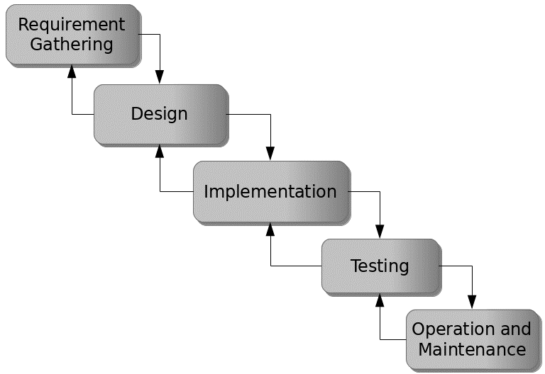

Figure 3.1: Waterfall model

## 3.5 Method of Data Collection

This study will adopt two methods of data collection:

**Primary Source:** Primary source refers to the sources of collecting original data in which the researcher makes use of empirical approach such as personal interview, questionnaires or observation.

**Secondary Source:** The need for the secondary sources of data for this kind of project cannot be over emphasized. The secondary data were obtained from magazines, Journal, newspapers, library source and most of the information from the library research has been covered in the literature review section.

## 3.6 System Design

Systems design is the process of defining the architecture, modules, interfaces, and data for a system to satisfy specified requirements. Systems design could be seen as the application of systems theory to product development.

## 3.6.1 Algorithm Diagram

**Use case diagram**

A use case diagram at its simplest is a representation of a user’s interaction with the system and depicting the specifications of a use case.

Registration

Login

Update Profile

Pay School Fee

Confirm Payment

Admin

Student (Guardian)

Check Result

View Classmates

Update System information

Print Result

Print Receipt

Log out

Figure 3.2: Use case diagram

**3.6.2 System Architecture**

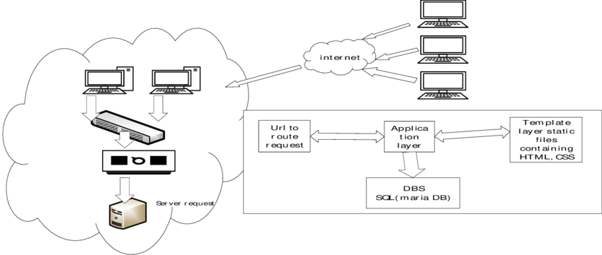

Figure 3.2: System Architecture

**3.6.3 Database Tables/Queries Structures**

## Table 3.1: Payment Table

|  |  |  |  |  |
| --- | --- | --- | --- | --- |
| **Field** | **Datatype (length)** | **Null** | **Key** | **Extra** |
| id | int(10) | NO | PRI | auto\_increment |
| Student name | varchar(50) | YES |  |  |
| Student Email | varchar(50) | YES |  |  |
| Student Phone | varchar(50) | YES |  |  |
| Student Class | varchar(50) |  |  |  |
| Amount Paid | varchar(50) |  |  |  |
| Reference id | varchar(50) |  |  |  |
| Date | timestamp |  |  |  |

#### Table 3.2: Classes Table

|  |  |  |  |  |  |
| --- | --- | --- | --- | --- | --- |
| **Field** | **Type** | **Null** | **Key** | **Default** | **Extra** |
| id | int(10) | NO | PRI |  | auto\_increment |
| classes | varchar(50) | YES |  |  |  |
| date\_added | varchar(50) | YES |  |  |  |
| time\_added | timestamp | YES |  | current\_timestamp() |  |

#### Table 3.3: Administratives Table

|  |  |  |  |  |  |
| --- | --- | --- | --- | --- | --- |
| **Field** | **Type** | **Null** | **Key** | **Default** | **Extra** |
| id | int(10) | NO | PRI |  | auto\_increment |
| school\_name | varchar(255) | YES |  |  |  |
| school\_motto | varchar(255) | YES |  |  |  |
| school\_logo | varchar(255) | YES |  |  |  |
| school\_stamp | varchar(255) | YES |  |  |  |
| upload\_date | varchar(50) | YES |  |  |  |
| upload\_time | timestamp | YES |  | current\_timestamp() |  |

#### Table 3.4: Current Session Table

|  |  |  |  |  |  |
| --- | --- | --- | --- | --- | --- |
| **Field** | **Type** | **Null** | **Key** | **Default** | **Extra** |
| id | int(10) | NO | PRI |  | auto\_increment |
| current\_session | varchar(20) | YES |  |  |  |
| current\_term | varchar(50) | YES |  |  |  |
| date\_declared | varchar(50) | YES |  |  |  |
| time\_declared | timestamp | YES |  | current\_timestamp() |  |

#### Table 3.5: Result Table

|  |  |  |  |  |  |
| --- | --- | --- | --- | --- | --- |
| **Field** | **Type** | **Null** | **Key** | **Default** | **Extra** |
| id | int(10) | NO | PRI |  | auto\_increment |
| class | varchar(10) | YES |  |  |  |
| term | varchar(50) | YES |  |  |  |
| session | varchar(50) | YES |  |  |  |
| reg\_number | varchar(50) | YES |  |  |  |
| name | varchar(50) | YES |  |  |  |
| subjects | varchar(100) | YES |  |  |  |
| ca | int(10) | YES |  |  |  |
| project | int(10) | YES |  |  |  |
| exam | int(10) | YES |  |  |  |
| subject\_total | int(10) | YES |  |  |  |
| subject\_rank | int(10) | YES |  |  |  |
| date\_of\_upload | varchar(20) | YES |  |  |  |
| time\_of\_upload | timestamp | NO |  | current\_timestamp() |  |

#### Table 3.6: Subjects

|  |  |  |  |  |  |
| --- | --- | --- | --- | --- | --- |
| **Field** | **Type** | **Null** | **Key** | **Default** | **Extra** |
| id | int(10) | NO | PRI |  | auto\_increment |
| reg\_number | varchar(100) | YES |  |  |  |
| name | varchar(100) | YES |  |  |  |
| class | varchar(20) | YES |  |  |  |
| subjects | varchar(100) | YES |  |  |  |
| term | varchar(50) | YES |  |  |  |
| session | varchar(50) | YES |  |  |  |
| registration\_date | varchar(20) | YES |  |  |  |
| registration\_time | timestamp | YES |  | current\_timestamp() |  |

#### Table 3.7: Students

|  |  |  |  |  |  |
| --- | --- | --- | --- | --- | --- |
| **Field** | **Type** | **Null** | **Key** | **Default** | **Extra** |
| id | int(10) | NO | PRI |  | auto\_increment |
| gender | varchar(20) | YES |  |  |  |
| firstname | varchar(50) | YES |  |  |  |
| lastname | varchar(50) | YES |  |  |  |
| othername | varchar(50) | YES |  |  |  |
| dob | varchar(50) | YES |  |  |  |
| mob | varchar(50) | YES |  |  |  |
| yob | varchar(50) | YES |  |  |  |
| contact\_phone | varchar(20) | YES |  |  |  |
| address | text | YES |  |  |  |
| lga | varchar(255) | NO |  |  |  |
| state | varchar(50) | YES |  |  |  |
| nationality | varchar(50) | YES |  |  |  |
| sponsor\_name | varchar(50) | YES |  |  |  |
| sponsor\_phone | varchar(20) | YES |  |  |  |
| relationship | varchar(20) | YES |  |  |  |
| class | varchar(20) | YES |  |  |  |
| reg\_number | varchar(100) | YES |  |  |  |
| gen\_password | varchar(20) | YES |  |  |  |
| passport | varchar(255) | YES |  |  |  |
| date\_of\_reg | varchar(20) | YES |  |  |  |
| time\_of\_reg | timestamp | YES |  | current\_timestamp() |  |

#### Table 3.8: Teachers

|  |  |  |  |  |  |
| --- | --- | --- | --- | --- | --- |
| **Field** | **Type** | **Null** | **Key** | **Default** | **Extra** |
| id | int(10) | NO | PRI |  | auto\_increment |
| title | varchar(50) | YES |  |  |  |
| fullname | varchar(100) | YES |  |  |  |
| address | text | YES |  |  |  |
| phone | varchar(50) | YES |  |  |  |
| state | varchar(50) | YES |  |  |  |
| lga | text | YES |  |  |  |
| nationality | varchar(50) | YES |  |  |  |
| email | varchar(50) | YES |  |  |  |
| password | varchar(50) | YES |  |  |  |
| date\_of\_reg | varchar(50) | YES |  |  |  |
| time\_of\_reg | timestamp | YES |  | current\_timestamp() |  |

#### Table 3.9: Users

|  |  |  |  |  |  |
| --- | --- | --- | --- | --- | --- |
| **Field** | **Type** | **Null** | **Key** | **Default** | **Extra** |
| id | int(10) | NO | PRI |  | auto\_increment |
| title | varchar(50) | YES |  |  |  |
| fullname | varchar(100) | YES |  |  |  |
| address | text | YES |  |  |  |
| phone | varchar(50) | YES |  |  |  |
| state | varchar(50) | YES |  |  |  |
| lga | text | YES |  |  |  |
| nationality | varchar(50) | YES |  |  |  |
| email | varchar(50) | YES |  |  |  |
| password | varchar(50) | YES |  |  |  |
| date\_of\_reg | varchar(50) | YES |  |  |  |
| time\_of\_reg | timestamp | YES |  | current\_timestamp() |  |

**3.6.4 Database Entity Relationship Diagram**

This shows the relationship of the various tables in the database with each other

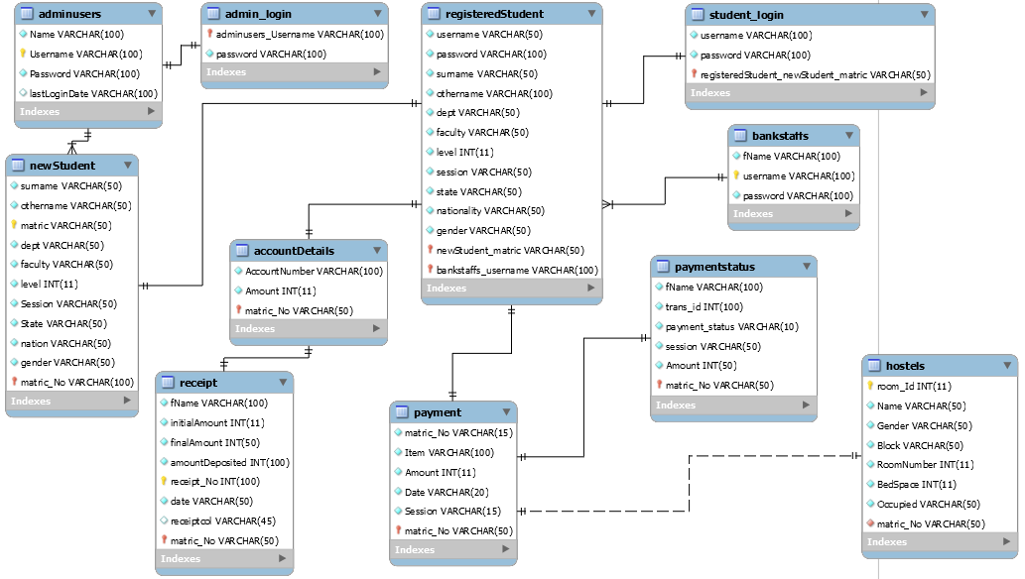

Figure 3.3: Database Entity Relationship Diagram

**3.6.5 The Input and Output Design**

Username or Registration Number

Enter Password

#### Don't Have an Account? [Create Account](http://localhost/school_dev/app.php#demanppopUpWindow)

Login

Figure 3.4: Login interface

CREATE PROFILE

Your Gender

User Type

First Name

Last Name

Phone Number

Email Address

Figure 3.5: Create Profile interface

**PAY WITH**

Card

Bank

Transfer

\*# USSD

amir@yahoo.com

Pay **47,000.00**

Use the test bank account provided below to complete this payment

Zenith Bank

2203002930

**Verify Account**

Figure 3.6: Payment interface

Gender

First Name (Surname)

Last Name

Other Name (Optional)

Email

Phone Number

Home Address

State of Origin

LGA of Origin

Day

Month

Year

Sponsor Name

Phone Number

Target Class

Relationship

REGISTER

Figure 3.7: Complete Registration interface

**CONFIRM PAYMENT**

Reference code

Figure 3.8: Payment confirmation interface

## 3.7 System Requirement Specification

**3.7.1 Hardware Requirements**

The software designed needed the following hardware for an effective operation of the newly designed system.

1. A system running on intel, P(R) duo core with higher processor
2. The-Random Access Memory (RAM) should be at least 512mb.
3. Enhanced keyboard.
4. At least 20-GB hard disk.
5. V.G.A or a colored monitor.

**3.7.2 Software Requirements**

The software requirements include:

1. A window 7 or higher version of operating system.
2. XAMP or WAMP for Database
3. PHP

## 3.7.3 Personnel Requirements

Any computer literate who has a technical knowhow of internet surfing can use the system because it is user friendly.

# CHAPTER FOUR

# RESULTS AND DISCUSSION

## 4.1 Introduction

Explain your new system’s operation that leads to the results below.

## 4.2 Results

Welcome Interface

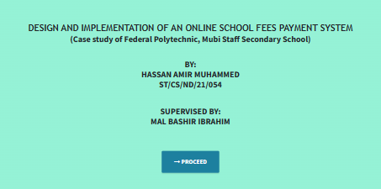

#### Figure 4.1: Welcome interface

Home page

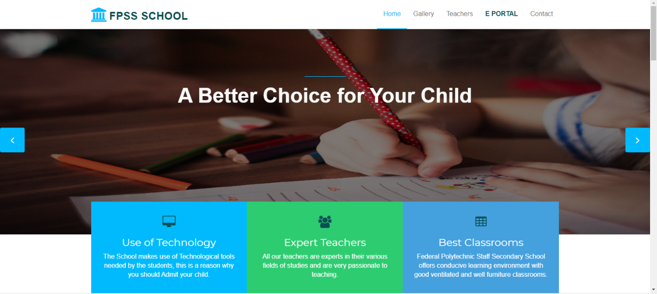

#### Figure 4.2: Home page interface

Login interface

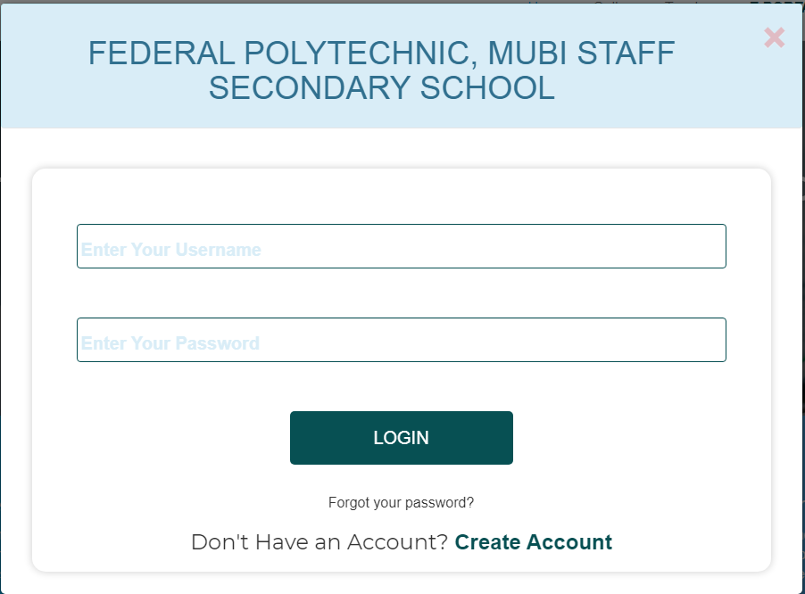

#### Figure 4.3: Login page interface

Signup interface

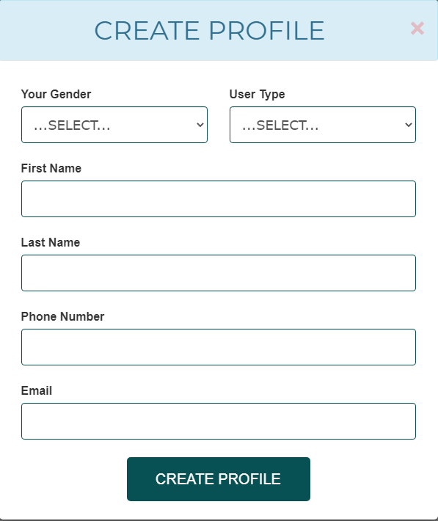

#### Figure 4.4: Signup page interface

Edit profile interface

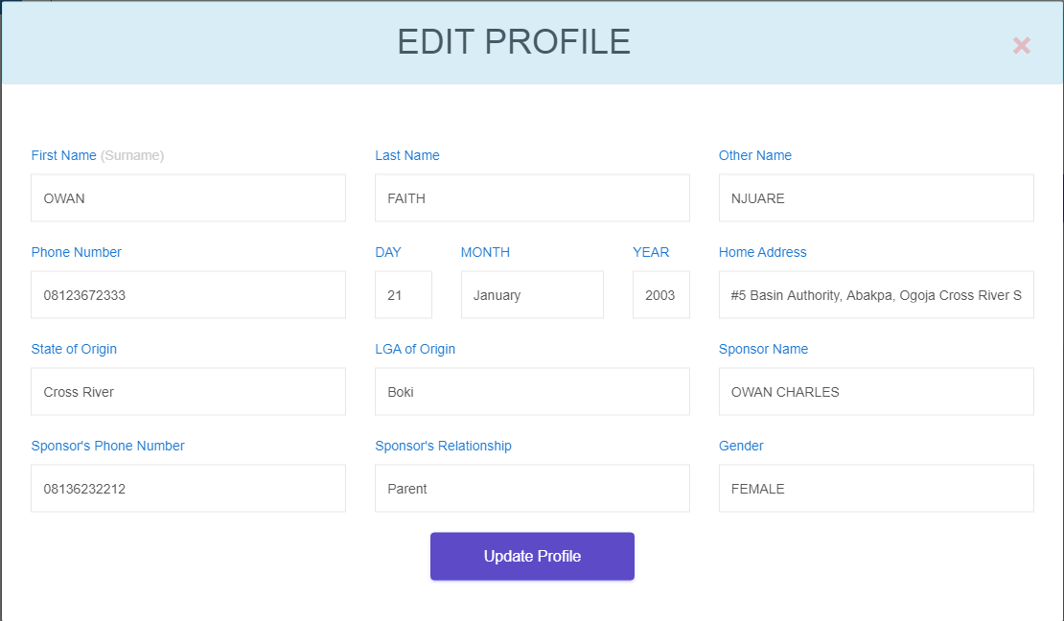

#### Figure 4.5: Edit profile page interface

Create announcement

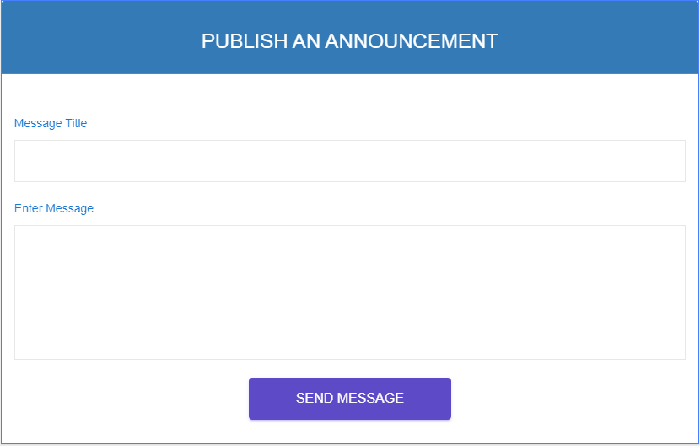

#### Figure 4.6: Create announcement interface

Announcement from Admin

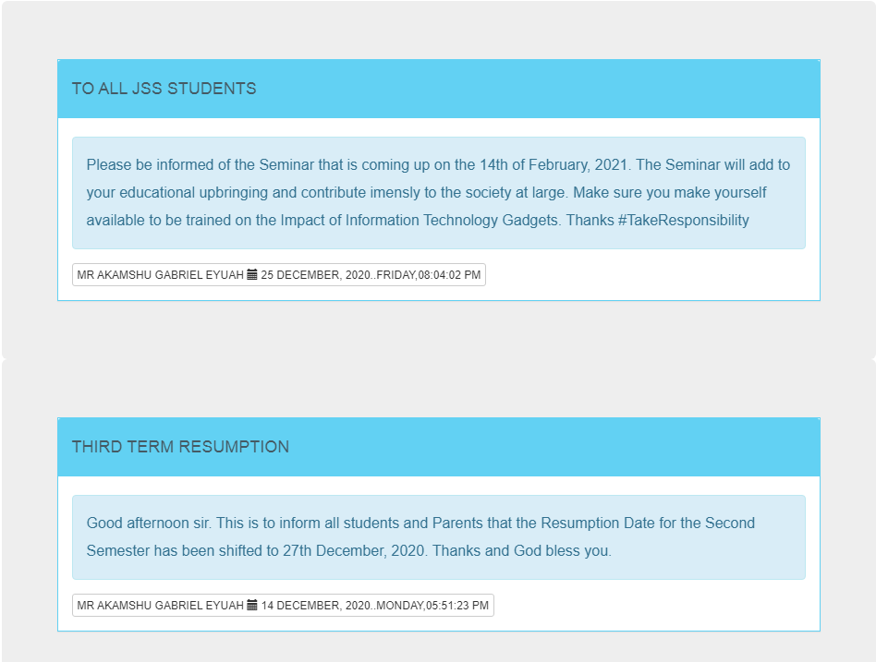

#### Figure 4.7: Announcement interface

Upload Result

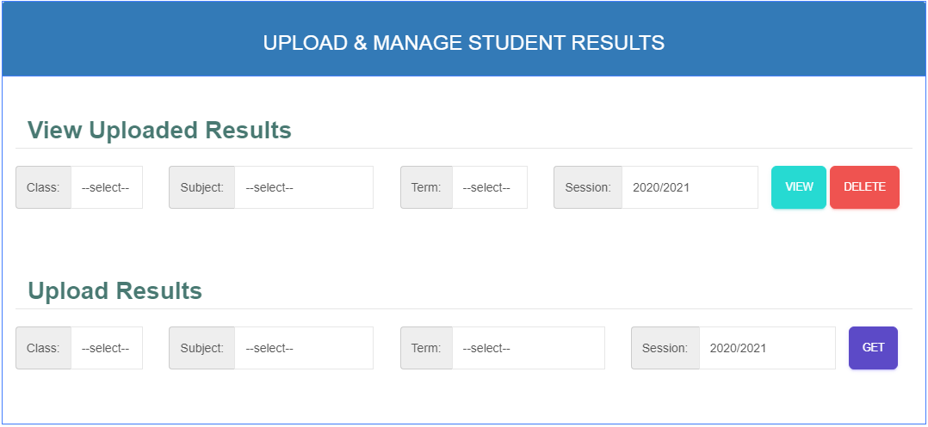

Figure 4.8: Upload result interface

Publish result

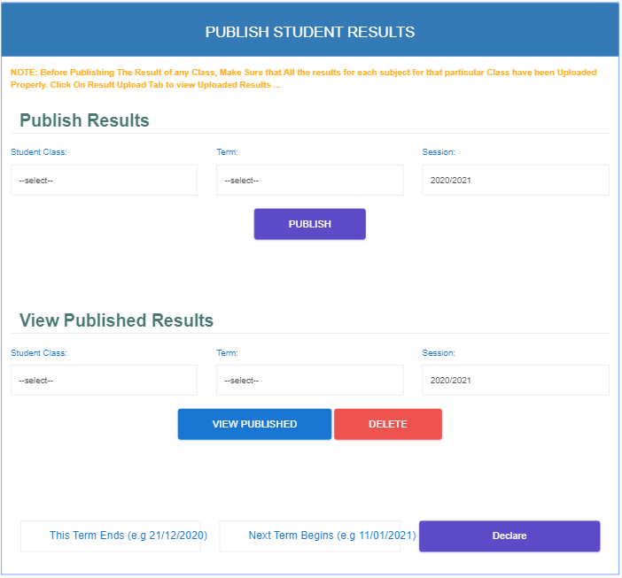

#### Figure 4.9: Publish result interface

Student registration slip

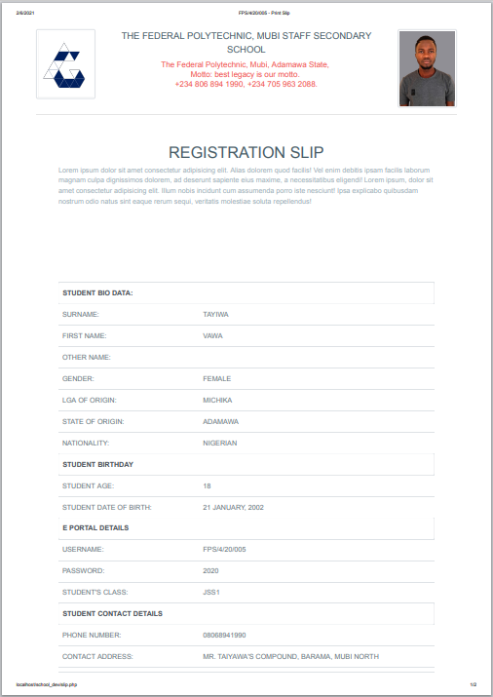

#### Figure 4.10: Student registration slip interface

Staff dashboard

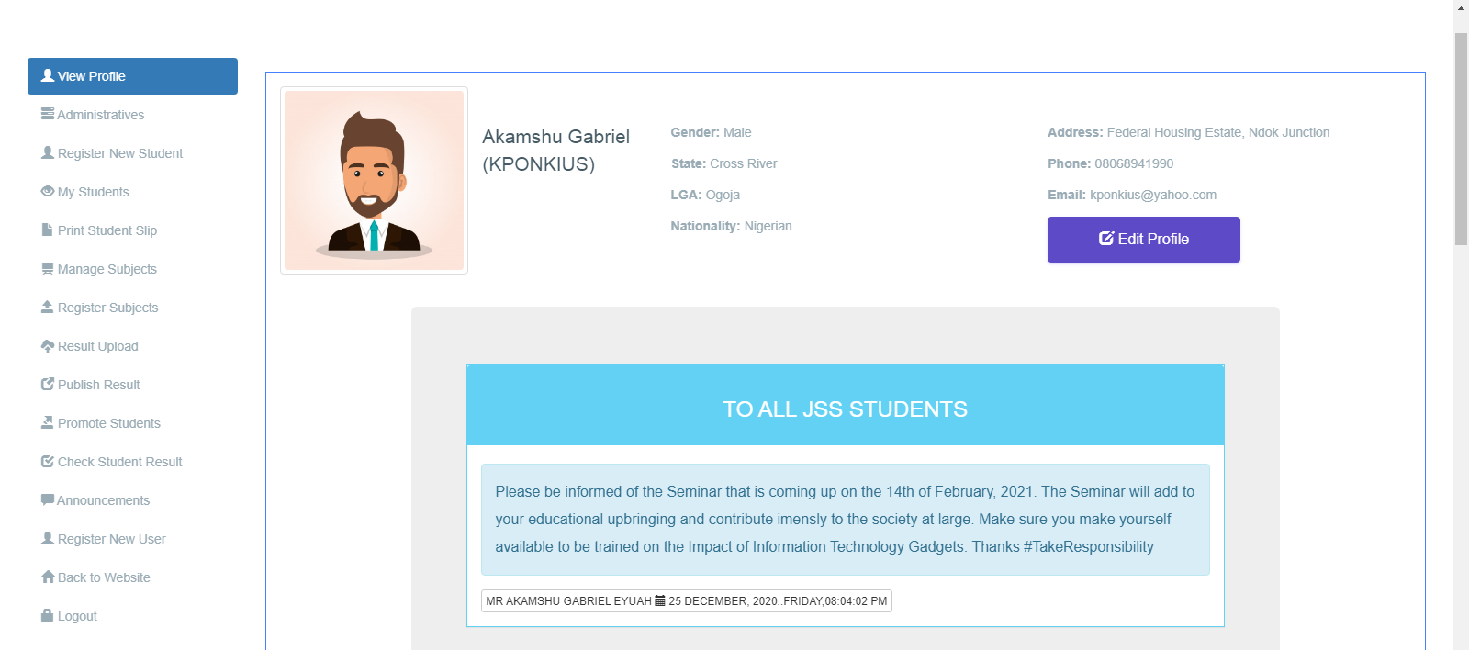

#### Figure 4.11: Staff dashboard interface

Student dashboard

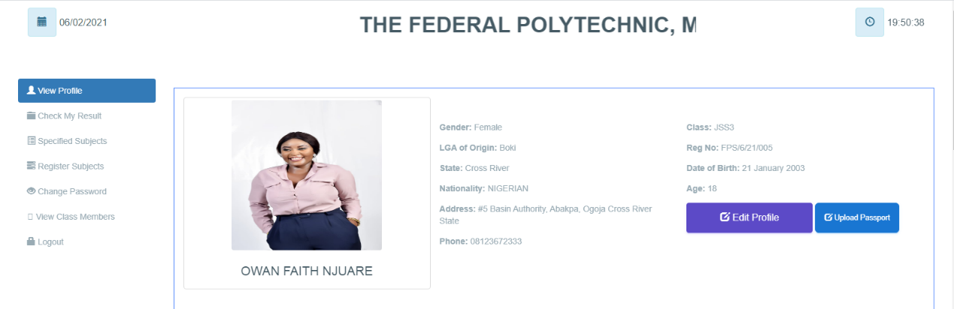

#### Figure 4.12: Student dashboard interface

## 

## 4.3 Discussion

**Welcome interface**

This is the very first interface which welcomes the user and shows the project topic, the designer and the supervisor of the project before proceeding to the main project.

**Home page**

This section displays the home page of the school portal where the user (student or staff) can go through the various facilities that the school has and where the login link for the portal is found as well.

**Login interface**

This section is used by an existing student or teacher to login into his or her account before completing any operation.

**Signup interface**

This is the signup page that allows the user to create an account with the school portal before he or she can complete any registration.

**Create announcement**

This section is used by the Admin (Principal) to pass information on the school portal to the students.

**Upload Result**

This section is used by the admin to upload results based on the data received from C.A. and exams marks appropriate for students on a particular subject. The admin (Principal) is allowed to upload result for all classes and subjects for all students.

**Publish result**

This section is only used by the admin to published all the various results that have been uploaded by the teachers or admin for result generation.

**Student registration slip**

This section is used to print the student registration slip that will be submitted to the school management and used to get the confirmation code from the management in order to generate a matric number.

**Staff or Student dashboard**

This is the admin dashboard that is used to display all the available operations that an admin, teacher or student can perform on the school the school portal.

## 4.4 User manual

The following are the necessary steps to take in order to use the system efficiently and effectively.

1. Load the url of the system <https://localhost/school_dev/> the welcome page will be displayed.
2. Click on the **Proceed** button to proceed to the main system.
3. Click on **E PORTAL** on the navigation bar to access the portal, the login interface will be displayed.
4. Click on the **Create Account** to create a profile account with the school portal.
5. Fill the form with your correct information to enable you create an account.
6. If you created an account, provide your login details by entering your username or Registration number and password.
7. Depending on the login details provided you will be automatically directed to the dashboard.
8. The various task that you can perform on the portal will be displayed on the sidebar of the dashboard.

# CHAPTER FIVE

# SUMMARY, CONCLUSION AND RECOMMENDATION

## 5.1 Summary

The new system was designed in such a way that records about of the student that of Federal Polytechnic, Mubi Staff Secondary school will be stored in a database for easy retrieval and manipulation of data that can be accessible from any place reducing the overcrowding in the management office for registration. The new system will also help the school to generate funds through the sale of Scratch cards.

## 5.2 Conclusion

The school fees payment system was designed and implemented, the aim and specific objectives of the project were achieved successfully.

## 5.3 Recommendations

The researcher puts forward the following recommendations:

1. The school management should imbibe the use of this technology in carrying out her tasks in order to reduce the time wastage that is involved with the manual system.
2. The researcher also recommends that the system be put to effective use in order to derive the necessary efficiency of the system.

## 5.4 Contribution to Knowledge

The new system was designed in a structured and robust way employing responsive design to it to ensure usability and efficiency. The project research will serve as a reference point for other research work and contribute immensely to knowledge for those conducting a research on similar topic.

## 5.5 Area for further work

The research work limited in making online payment. Therefore, the researcher suggests that further studies be conducted to include the payment of fees online.

# REFERENCES

Abuhamdieh, H. & Sehwail, L. (2017). A comparative study of campus portal user acceptance: Student and faculty perspectives Journal of STEM Education, 8(34), 40-49.

Adepoju, S. & Osofisan, O. (2018). Website usability: A comparison of three universities websites. Journal of Science, Technology and Mathematics Education, 1(1), 114-121.

Astani, M. & Elhindi, M. (2018). An empirical study of university websites. Journal of Information Systems, 10(2), 460-465.

Allan, H. (2014). Measuring campus portal effectiveness and the contributing factors. Campus-Wide Journal of Information Systems, 24(5), 342-354. doi:10.1108/10650740710835760.

Babbie, E. (2014). The Practice of Social Research. Belmont, CA: Thomson/Wadsworth.

Brayand, G. (2014). The impact of website portals: research synthesis. Journal of Information Systems, 16(1), 7-30. doi:10.2308/jis.2002.16.1.7

Boye, M. (2015). Educational Portals: A way to get integrated, user-centric university information systems. International journal of information services, 8(1), 17-23.

Bringula, R., & Basa, S. (2016). Factors affecting faculty web porta! usability. Journal of Educational Technology & Society, 14 (4), 253-265.

Cappel, J. & Huang, Z. (2017). A usability analysis of company websites. Journal of Computer Information Systems, 48(1), 117-123.

Chen, S., Li, S. & Li, C. (2014). Recent related research in technology acceptance model: A literature reviews Australian Journal of Business and Management Research, 1(9), 124-127.

Davis, F. (2019). Perceived usefulness, perceived ease of use, and user acceptance of information technology. Journal of Management Information System, 13(3), 319-340.

Doll, J. & Torkzadeh, A. (1988). White paper eleven enterprise web customer case studies: Plumtree Software, San Francisco, CA

Fuangvut, J. & Hasan, D. (2015). Begin with the end (user) in mind: Planning for the San Diego State University campus portal. In Jafari, A., & Sheehan, M. (Eds.), Designing Portals: Opportunities and Challenges (127-161). PA: Hershey.

Gerd, J. (2015). Measuring campus portal effectiveness and the contributing factors. Campus-Wide Journal of Information Systems, 24(5), 342-354. doi:10.1108/10650740710835760.

Hasan, H. (2013). Accommodating inter-generational stakeholders in a campus portal. Retrieved January 11, 2020, from <http://www.iseing.org/emcis/EMCIS2005/pdfs/22.pdf>

Hasan, L. (2013). Using university ranking systems to predict usability of university websites. Journal of Information Systems and Technology Management, 10(2), 235 250 DOI: 10.4301/S1807-17752013000200003 ISO 9241-11 (1998).

Ives, B. (2013). The measurement of user information satisfaction. Journal of communication, 26(10), 785-793. doi:10.1145/358413.358430

Lim, H. (2014). Cross cultural differences in online learning motivation. Paper presented at the Academy of Human Resources Development International Conference. Retrieved November 27, 2020 from http;//www.editlib.org/p/59841.

Lim, K. (2014). The role of corporate portal on consolidating an organization’s internal and external information and knowledge repositories. Retrieved February 12, 2020 from http:/Avww.bing.com/search?q=Full+Text+Mobile+PDF&src=IE-SearchBox&FORM=IE8SRC

Mahmood, M., Burn, J., Gemoets, L., & Jacquez, C. (2010). Variables affecting information technology end-user satisfaction: A meta-analysis of the empirical literature. International Journal of Human-Computer Studies, 52(5), 751-771. doi:10.1006/ijhc.1999.0353.

Masrek, N. (2017). Measuring campus portal effectiveness and the contributing factors. Campus-Wide Journal of Information Systems, 24(5), 342-354. doi:10.1108/10650740710835760.

McKinney, V., Yoon, K., & Zahedi, F. (2012). The measurement of web-customer satisfaction: An expectation and disconfirmation approach. Journal of Information System Research, 13(3), 296-315.

Mentes, S. & Turan, H. (2012). Assessing the usability of university websites: An emipirical study on Namik Kemal University. Turkish Online Journal of Educational Technology, 2 (3), 61-69.

Moskowitz, R. (2011). Campus portals: Come to higher education. Matrix: The Magazine for Leaders in Higher Education, 2(3), 54(3).

Okene, F. & Enukpere, V. (2011). Comparative analysis of the usability of academic websites of Delta State Polytechnics. Journal of Emerging Trends in Engineering and Applied Sciences, 2(6), 1042-1046.

Olalekan, A. & Adepoju, T. (2012). Usability study of some selected functional websites in Nigeria. African Journal of Computing & Information Communication Technology, 5 (3), 57-70.

Ovem, J. (2015). Designing Portals: Opportunities and Challenges. Hershey, PA: Information Science Publishing, New Jersey.

Pierce, K. (2015). Web site usability report for Harvard University. Retrieved 24" November, 2020 from <http://digitalcommons.utep.edu/cgi/viewcontent.ogi?>

Pierece, A. (2015). An Overview of corporate portal technology and development: Survey results from organizations that have deployed corporate portal. Retrieved July 8, 2020 from <http://www.plumtree.com/pdf/>

Rai, A. (2012). Assessing the validity of IS success models: An empirical test and theoretical analysis. Information Systems Research Journal, 13(1), 50-69. doi:10.1287/isre.13.1. 50. 96

Rao, S. (2013). Distance education and the role of IT in India. The Electronic Library, 24(3), 225-236. doi:10.1108/026404706 10660396

Reus, A. (2013). Assessing the validity of IS success models: An empirical test and theoretical analysis. Information Systems Research Journal, 13(1), 50-69. doi:10.1287/isre.13.1.50.96

Richard, V. (2016). Returns on investments in information technology: A research synthesis. Journal of Information Systems, 16(1), 7-30. doi:10.2308/jis.2002.16.1.7

Roberts-Witt, S. (2019). User satisfaction with business-to-employee \_ portals: Conceptualization and scale development. European Journal of Information Systems, 17(6), 649-667. doi:10.1057/ejis.2008.55

Sharma, S. & Gupta, J. (2015). Web portals: The new gateways to Internet information and services. Idea Group Publishing: Hershey

Sugianto, L., & Tojib, D. R. (2017). Facilitating Employees with B2E Portal. In Proceedings of the 7" International Research Conference on Quality Innovation and Knowledge Management (pp. 553-560).

Tella, A. & Bashorun, T. (2012). Undergraduate students’ satisfaction with the use of web portals. International Journal of Web Portals 4(2), 52-73. DOI: 10.4018/jwp.2012040104h

Tojib, S. (2018). A conceptual model for B2E portal model satisfaction. Retrieved May 12, 2020 from <https://bai2006.atisr.org/CD/Papers/2006bai6315.doc>

Worjtkowski, W. & Major, M. (2015). Online portals: The new gateways to Internet information and services. Idea Group Publishing: Hershey

Zaphiris, P. & Ellis, D. (2013). Website usability and content accessibility of the top USA universities. Retrieved February 4, 2021 from <http://pzaphiri.agrino.org/Papers/accessibilitywebnet.pdf>

# APPENDIX A

Welcome interface



Home page



Login interface



Signup interface



Edit profile interface



Create announcement



Announcement from Admin



Upload Result



Publish result



Student registration slip



Staff dashboard



Student dashboard



# APPENDIX B

**PROGRAM CODE**

|  |  |
| --- | --- |
|  |  |
|  |  |
|  |  |
|  | <!DOCTYPE html> |
|  | <html lang="en"> |
|  | <head> |
|  | <meta charset="utf-8"> |
|  | <meta http-equiv="X-UA-Compatible" content="IE=edge"> |
|  | <meta name="viewport" content="width=device-width, initial-scale=1"> |
|  | <title>FPS Secondary School | Home</title> |
|  |  |
|  | <!-- Favicon --> |
|  | <link rel="shortcut icon" href="[assets/img/favicon.ico](http://localhost/school_dev/assets/img/favicon.ico)" type="image/x-icon"> |
|  |  |
|  | <!-- Font awesome --> |
|  | <link href="[assets/css/font-awesome.css](http://localhost/school_dev/assets/css/font-awesome.css)" rel="stylesheet"> |
|  |  |
|  |  |
|  | <!-- Bootstrap --> |
|  | <link href="[assets/css/bootstrap.css](http://localhost/school_dev/assets/css/bootstrap.css)" rel="stylesheet"> |
|  | <!-- Slick slider --> |
|  | <link rel="stylesheet" type="text/css" href="[assets/css/slick.css](http://localhost/school_dev/assets/css/slick.css)"> |
|  | <!-- Fancybox slider --> |
|  | <link rel="stylesheet" href="[assets/css/jquery.fancybox.css](http://localhost/school_dev/assets/css/jquery.fancybox.css)" type="text/css" media="screen" /> |
|  | <!-- Theme color --> |
|  | <link id="switcher" href="[assets/css/theme-color/default-theme.css](http://localhost/school_dev/assets/css/theme-color/default-theme.css)" rel="stylesheet"> |
|  |  |
|  | <!-- Main style sheet --> |
|  | <link href="[assets/css/style.css](http://localhost/school_dev/assets/css/style.css)" rel="stylesheet"> |
|  | <link rel="stylesheet" href="[popup\_style.css](http://localhost/school_dev/popup_style.css)"> |
|  |  |
|  | <!-- Google Fonts --> |
|  | <link href='<https://fonts.googleapis.com/css?family=Montserrat:400,700>' rel='stylesheet' type='text/css'> |
|  | <link href='<https://fonts.googleapis.com/css?family=Roboto:400,400italic,300,300italic,500,700>' rel='stylesheet' type='text/css'> |
|  |  |
|  |  |
|  | </head> |
|  | <body> |
|  |  |
|  |  |
|  |  |
|  |  |
|  | <!--START SCROLL TOP BUTTON --> |
|  | <a class="scrollToTop" href="[#](http://localhost/school_dev/app.php)"> |
|  | <i class="fa fa-angle-up"></i> |
|  | </a> |
|  | <!-- END SCROLL TOP BUTTON --> |
|  |  |
|  | <!-- LOADER --> |
|  | <div id="preloader"> |
|  | <div class="loader-container"> |
|  | <div class="progress-br float shadow"> |
|  | <div class="progress\_\_item"></div> |
|  | </div> |
|  | </div> |
|  | </div> |
|  | <!-- END LOADER --> |
|  |  |
|  | <!-- Start menu --> |
|  | <section id="mu-menu"> |
|  | <nav class="navbar navbar-default" role="navigation"> |
|  | <div class="container"> |
|  | <div class="navbar-header"> |
|  | <!-- FOR MOBILE VIEW COLLAPSED BUTTON --> |
|  | <button type="button" class="navbar-toggle collapsed" data-toggle="collapse" data-target="#navbar" aria-expanded="false" aria-controls="navbar"> |
|  | <span class="sr-only">Toggle navigation</span> |
|  | <span class="icon-bar"></span> |
|  | <span class="icon-bar"></span> |
|  | <span class="icon-bar"></span> |
|  | </button> |
|  | <!-- LOGO --> |
|  | <!-- TEXT BASED LOGO --> |
|  | <a class="navbar-brand" href="[index.html](http://localhost/school_dev/index.html)"><i class="fa fa-university"></i><span>FPSS School</span></a> |
|  | <!-- IMG BASED LOGO --> |
|  | <!-- <a class="navbar-brand" href="index.html"><img src="assets/img/logo.png" alt="logo"></a> --> |
|  | </div> |
|  | <div id="navbar" class="navbar-collapse collapse"> |
|  | <ul id="top-menu" class="nav navbar-nav navbar-right main-nav"> |
|  | <li class="active"><a href="[index.html](http://localhost/school_dev/index.html)">Home</a></li> |
|  | <li><a href="[#mu-gallery](http://localhost/school_dev/app.php#mu-gallery)">Gallery</a></li> |
|  | <li class="nav-item"><a class="nav-link" href="[#mu-latest-courses](http://localhost/school_dev/app.php#mu-latest-courses)">Teachers</a></li> |
|  | <li><a class="hover-btn-new log orange" href="[#login](http://localhost/school_dev/app.php#login)" |
|  | data-toggle="modal" data-target="#login"><span>E PORTAL</span></a></li> |
|  | <li><a href="[#](http://localhost/school_dev/app.php)">Contact</a></li> |
|  | <li></li> |
|  | </ul> |
|  | </div><!--/.nav-collapse --> |
|  | </div> |
|  | </nav> |
|  | </section> |
|  | <!-- End menu --> |
|  | <!-- Start search box --> |
|  | <div id="mu-search"> |
|  | <div class="mu-search-area"> |
|  | <button class="mu-search-close"><span class="fa fa-close"></span></button> |
|  | <div class="container"> |
|  | <div class="row"> |
|  | <div class="col-md-12"> |
|  | <form class="mu-search-form"> |
|  | <input type="search" placeholder="Type Your Keyword(s) & Hit Enter"> |
|  | </form> |
|  | </div> |
|  | </div> |
|  | </div> |
|  | </div> |
|  | </div> |
|  | <!-- End search box --> |
|  |  |
|  |  |
|  |  |
|  |  |
|  |  |
|  | <!-- Modal --> |
|  | <div data-backdrop='static' class="modal fade" id="login" tabindex="-1" role="dialog" aria-labelledby="myModalLabel"> |
|  | <div class="modal-dialog modal-dialog-centered modal-md" role="document"> |
|  | <div class="modal-content"> |
|  | <div class="modal-header tit-up alert alert-info"> |
|  | <button type="button" class="close" style='color:red; font-size:50px;' data-dismiss="modal" aria-hidden="true">&times;</button> |
|  | <h1 class='h1 text-center' style='text-transform:uppercase; max-width:95%;'>Federal Polytechnic, Mubi Staff Secondary School</h1> |
|  | </div> |
|  |  |
|  | <div class="modal-body"> |
|  | <!-- <h1 style='text-align:center;'>LOGIN TO YOUR ACCOUNT</h1> --> |
|  | <div class="inner" id="Login" > |
|  | <form autocomplete="autocomplete\_off\_kponk" method='POST' action="/school\_dev/app.php" > |
|  | <br> |
|  | <!-- <input name='hidden' class="form-control" id="" placeholder=" " type="text" autocomplete='false' style='display:none;'> --> |
|  |  |
|  | <label class="form-group" for="email1"> |
|  | <input name='login\_id' class="form-control" id="email1" placeholder=" " type="text" autocomplete="off\_kponk" required> |
|  | <span>Enter Your Username </span> |
|  | <span class='border'></span> |
|  | </label> |
|  |  |
|  | <label class="form-group" for="exampleInputPassword1"> |
|  | <input class="form-control" id="exampleInputPassword1" placeholder=" " name="login\_password" type="password" autocomplete='kponk\_off' required> |
|  | <span>Enter Your Password</span> |
|  | <span class='border'></span> |
|  | </label> |
|  | <div class="row text-center"> |
|  | <p class='text-center'><input type="submit" name="login\_btn" class="" value="LOGIN"></p> |
|  |  |
|  | <p lass="text-center" ><a href="[javascript:;](about:blank" \t "_blank)">Forgot your password?</a></p> |
|  | <h4> Don't Have an Account? <a href="[#demanppopUpWindow](http://localhost/school_dev/app.php#demanppopUpWindow)" data-toggle="modal" data-target="#demanppopUpWindow" data-dismiss="modal" > <span>Create Account</span></a> </h4> |
|  | </div> |
|  | </form> |
|  | </div> |
|  | </div> |
|  | </div> |
|  | </div> |
|  | </div> |
|  |  |
|  |  |
|  | <!-- Start Slider --> |
|  | <section id="mu-slider"> |
|  | <!-- Start single slider item --> |
|  | <div class="mu-slider-single"> |
|  | <div class="mu-slider-img"> |
|  | <figure> |
|  | <img src="[assets/img/slider/4.jpg](http://localhost/school_dev/assets/img/slider/4.jpg)" alt="img"> |
|  | </figure> |
|  | </div> |
|  | <div class="mu-slider-content"> |
|  | <span></span> |
|  | <h2>We Will Help Your Child/Ward To Learn</h2> |
|  | </div> |
|  | </div> |
|  | <!-- Start single slider item --> |
|  | <!-- Start single slider item --> |
|  | <div class="mu-slider-single"> |
|  | <div class="mu-slider-img"> |
|  | <figure> |
|  | <img src="[assets/img/slider/8.jpg](http://localhost/school_dev/assets/img/slider/8.jpg)" alt="img"> |
|  | </figure> |
|  | </div> |
|  | <div class="mu-slider-content"> |
|  | <span></span> |
|  | <h2>A Better Choice for Your Child</h2> |
|  |  |
|  | </div> |
|  | </div> |
|  | <!-- Start single slider item --> |
|  | <!-- Start single slider item --> |
|  | <div class="mu-slider-single"> |
|  | <div class="mu-slider-img"> |
|  | <figure> |
|  | <img src="[assets/img/slider/9.jpg](http://localhost/school_dev/assets/img/slider/9.jpg)" alt="img"> |
|  | </figure> |
|  | </div> |
|  | <div class="mu-slider-content"> |
|  | <span></span> |
|  | <h2>"Train up a child in the way he should grow"</h2> |
|  |  |
|  | </div> |
|  | </div> |
|  | <!-- Start single slider item --> |
|  | <!-- Start single slider item --> |
|  | <div class="mu-slider-single"> |
|  | <div class="mu-slider-img"> |
|  | <figure> |
|  | <img src="[assets/img/slider/10.jpg](http://localhost/school_dev/assets/img/slider/10.jpg)" alt="img"> |
|  | </figure> |
|  | </div> |
|  | <div class="mu-slider-content"> |
|  | <span></span> |
|  | <h2>Five Times Award for Best Secondary School</h2> |
|  | </div> |
|  | </div> |
|  | <!-- Start single slider item --> |
|  | <!-- Start single slider item --> |
|  | <div class="mu-slider-single"> |
|  | <div class="mu-slider-img"> |
|  | <figure> |
|  |  |
|  |  |
|  |  |
|  | <!-- jQuery library --> |
|  | <script src="[assets/js/jquery.min.js](http://localhost/school_dev/assets/js/jquery.min.js)"></script> |
|  | <!-- Include all compiled plugins (below), or include individual files as needed --> |
|  | <script src="[assets/js/bootstrap.js](http://localhost/school_dev/assets/js/bootstrap.js)"></script> |
|  | <!-- Slick slider --> |
|  | <script type="text/javascript" src="[assets/js/slick.js](http://localhost/school_dev/assets/js/slick.js)"></script> |
|  | <!-- Counter --> |
|  | <script type="text/javascript" src="[assets/js/waypoints.js](http://localhost/school_dev/assets/js/waypoints.js)"></script> |
|  | <script type="text/javascript" src="[assets/js/jquery.counterup.js](http://localhost/school_dev/assets/js/jquery.counterup.js)"></script> |
|  | <!-- Mixit slider --> |
|  | <script type="text/javascript" src="[assets/js/jquery.mixitup.js](http://localhost/school_dev/assets/js/jquery.mixitup.js)"></script> |
|  | <!-- Add fancyBox --> |
|  | <script type="text/javascript" src="[assets/js/jquery.fancybox.pack.js](http://localhost/school_dev/assets/js/jquery.fancybox.pack.js)"></script> |
|  |  |
|  | <script> |
|  |  |
|  |  |
|  | function isInputNumber(evt) { |
|  | let char = String.fromCharCode (evt.which); |
|  | if(!(/[0-9]/.test(char))){ |
|  | evt.preventDefault(); |
|  | } |
|  |  |
|  | } |
|  | </script> |
|  | <!-- Custom js --> |
|  | <script src="[assets/js/custom.js](http://localhost/school_dev/assets/js/custom.js)"></script> |
|  |  |
|  | </body> |
|  | </html> |

**REFERENCES**

Adamu, A. A., Alhassan, A. M., & Abdulmumini, Y. (2021). Implementation of an online school fee payment system in Nigerian universities. Journal of Information Technology Impact, 21(1), 1-13.

Alcott, B., & Rose, H. (2021). The Effects of School Fees on Student Enrollment and Achievement: Evidence from Rural Malawi. Journal of Development Economics, 150, 102611.

Al-Khouri, A. M., & Abu-Jarour, S. A. (2020). The Role of Information Systems in Enhancing Knowledge Sharing and Collaboration: A Case Study. International Journal of Information Management, 50, 261-269.

Balogun, T., & Adetokunboh, O. (2021). Assessing the effects of an online payment system on the performance of educational institutions. International Journal of Educational Technology in Higher Education, 18(1), 40.

Chang, V., & King, D. (2020). Information Management in the Cloud. In Strategic Management in the Digital Age (pp. 251-274). Springer.

Chen, Y., & Chen, J. (2021). Understanding the Motivation and Adoption of Mobile Payment: An Empirical Study of WeChat Pay. Journal of Theoretical and Applied Electronic Commerce Research, 16(4), 883-900.

Delen, D. (2021). Advanced Data Analytics and Business Intelligence: A Comparative Analysis of Descriptive, Predictive, and Prescriptive Techniques. Business Process Management Journal, 27(1), 194-212.

Devi, S., & Rani, S. (2021). Online school fee payment system: Challenges faced by parents and schools. International Journal of Trend in Research and Development, 8(1), 1190-1193.

Elmasri, R., & Navathe, S. B. (2019). Fundamentals of Database Systems. Pearson.

Ghazal, A., Rabl, T., Hu, M., Raab, F., Poess, M., & Crolotte, A. (2020). NoSQL Databases for Big Data Analytics: A Comprehensive Overview. ACM Computing Surveys (CSUR), 53(2), 1-38.

Huang, S. H., Chen, H. L., & Yeh, T. M. (2021). Conceptualizing Digital Transformation: The Effect of Digital Innovativeness, Digital Transformation Strategy, and Organizational Absorptive Capacity on Digital Transformation Performance. Information & Management, 58(2), 103378.

Huang, T. H., & Lu, H. P. (2020). Smart Campus Innovation: Examining the Relationship among Administrative Efficiency, Organizational Agility, and Sustainability Performance. Sustainability, 12(10), 4081.

Jelena, J., & Zoran, P. (2020). Online Fee Payment System in Primary Schools. TEM Journal, 9(3), 1047-1055.

Kao, Y. L., & Li, Y. (2020). A Study of the Implementation of an Online Payment System in an Educational Institution. Journal of Educational Media & Library Sciences, 57(3), 281-305.

Khumalo, T. (2020). Information Management Systems for Small and Medium Enterprises. Journal of Enterprise Information Management, 33(4), 616-633.

Lee, Y., & Koo, C. (2021). Does Open Data Foster Digital Government? The Mediating Role of Database Integration. Information Systems Frontiers, 23(1), 131-145.

Li, X., Xu, D., & Ma, D. (2020). A Multi-Agent Framework for Building Learning Service Portals. Journal of Ambient Intelligence and Humanized Computing, 11(6), 2531-2546.

Motahari-Nezhad, H. R., Stephenson, B., & Singhal, S. (2021). Data Management and Data Platforms. In Architecting the Cloud (pp. 69-100). Morgan Kaufmann.

Ramakrishnan, R., & Gehrke, J. (2020). Database Management Systems. McGraw-Hill Education.

Rizvi, A., Tanweer, S., Abbas, M., & Khan, A. A. (2021). A Comparative Study of Various Database Management Systems (DBMS). In 2021 International Conference on Intelligent Systems, Metaheuristics & Swarm Intelligence (ISMSI) (pp. 1-6). IEEE.

Srivastava, G., & Sushil. (2021). Information Security Management in the Era of Artificial Intelligence and Big Data: State-of-the-Art and Challenges. Journal of Enterprise Information Management, 34(4), 834-853.

Sutanto, J., Palme, E., & Chua, C. E. H. (2020). Examining the Role of Perceived Risk in Mobile Payment Services Adoption. Journal of Business Research, 113, 230-240.

Thakur, R., & Kotecha, K. (2020). Impact of online fee payment system on Indian school administration. International Journal of Research in Engineering, Science and Management, 3(1), 269-274.

Wahyudi, A. A., Wicaksono, S., & Wahyudi, A. S. (2021). The Adoption of E-Payment System in Government Organization in Indonesia. Journal of Open Innovation: Technology, Market, and Complexity, 7(4), 217.

Wang, J., Ding, Y., & Wang, Q. (2021). The Application of Big Data Analytics in Business. Journal of Big Data, 8(1), 1-24.

Wang, W. Y., Liu, Y., & Lee, G. (2021). Investigating the Impact of Information Management on Organizational Performance. Information & Management, 58(1), 103312.

Wu, C. J., Li, S. H., & Zhao, C. (2020). Data Integration in E-Government Services: A Systematic Literature Review. Information Systems Management, 37(4), 327-341.

Yusoff, M. Z., & Mohamad, N. A. (2021). Evaluation of User-Friendly Attributes in Mobile Learning Application for Primary School Students. Journal of Physics: Conference Series, 1822(1), 012067.